Saheli Sahaay: personalised digital support for widows

Introduction
Saheli Sahaay is a multilingual, voice-enabled support platform for widows in India. It combines scheme discovery, verified service referrals, emotional-support triage, livelihood and credit navigation, emergency help, and human case management in one guided experience. The product should complement—not replace—government portals, clinicians, banks, NGOs, or emergency services.
The gap is not simply a lack of scheme information. myScheme already provides a national marketplace for government schemes and reduces the need to search multiple departmental websites[1]. NSAP already supports widow, disability, and old-age pensions, application/status tracking, mobile submission, Aadhaar authentication with consent, and nearby bank/post-office discovery[2]. The proposed product adds a personalised layer: it asks only relevant questions, explains eligibility in the user's language, routes the user to verified help, follows up on unresolved cases, and preserves a consented support history.

2. Product concept

Proposed name
Saheli Sahaay — your trusted support companion

Four primary user categories
- Young widow — benefits navigation, education/re-skilling, safe employment, counselling, and financial inclusion.
- Older widow — pension, health access, home support, banking, emergency contacts, and assisted voice navigation.
- Widow with children — children's education, nutrition, scholarships, childcare, housing, income support, and legal documentation.
- Widow with disability — accessible navigation, disability certification, assistive services, pension, mobility, home-based livelihoods, and caregiver support.
These categories are a starting taxonomy, not labels shown in a stigmatizing way. A user can belong to more than one category, and the system should permit self-description and correction.

3. Core modules

Personalised chatbot
A conversational assistant collects minimal profile information, explains why each question is needed, and recommends next actions. It should support text, voice notes, speech-to-text, text-to-speech, large text, high contrast, screen readers, and low-bandwidth mode. Hindi plus regional languages should be prioritised through a pilot with real users; translated content must be reviewed by native speakers.

Special-aid and emergency layer
A persistent Help Now control should provide locally configured emergency numbers, domestic-violence and child-protection escalation, crisis support, ambulance/police/fire contacts, and a trusted-contact workflow. The bot must distinguish emotional distress from imminent danger. It should never present itself as a psychiatrist; it should triage, provide supportive conversation, and route to a licensed professional or emergency service when required.

Psychiatrist and counsellor portal
The portal should support verified professional onboarding, license/credential checks, appointment slots, referral notes, consent-based case summaries, escalation flags, outcome notes, and audit logs. High-risk conversations should be routed to trained human responders rather than handled autonomously.

Scheme and service navigator
The scheme layer should use official source links, eligibility rules, required documents, state/district availability, application status, and a “last verified” date. NSAP is a useful integration reference because its official site exposes scheme eligibility, application tracking, payment tracking, FAQs, and mobile submission[2]. The platform should link out to the authoritative application channel instead of collecting unnecessary identity documents.

Livelihoods, credits, and CSR bank partnerships
The livelihood module can connect users to SHGs, training, verified employers, market access, and bank/CSR programmes. HDFC Bank's Sustainable Livelihood Initiative describes collateral-free lending and support for activities such as livestock rearing, handicrafts, tailoring, jewellery design, and grocery shops[3]. Central Bank of India's Women Entrepreneur Cell describes training, project-report support, SHG formation, credit linkages, women-focused products, and a business-women directory[4]. The prototype should display these as partner offers or referral pathways, never as guaranteed loans or benefits.

Support-ticket layer
Every unresolved request receives a ticket number, owner, status, next action, expected response time, language preference, and consent history. Escalation rules should cover missed deadlines, repeated failed referrals, safeguarding concerns, and inability to access an essential benefit.

4. Suggested user journey
- User selects language and voice/text mode.
- The bot asks consent and offers anonymous browsing.
- User chooses a need: documents, health, safety, work, counselling, disability support, or emergency.
- The bot asks only the minimum profile questions needed for routing.
- A rules engine classifies the user into one or more support segments.
- They can select services according to their needs by giving credits per order.
- The user receives a short answer, source link, required-document checklist, and next action.
- The user can ask a follow-up question, hear the answer, save it, or open a support ticket.
- Human staff review exceptions and high-risk cases.
- The user receives reminders and can close or correct the case.

5. Proposed security and verification architecture

Government/security layer
- Use official government domains and signed source records for schemes.
- Maintain a source registry with owner, URL, state, language, verification date, and expiry/review date.
- Separate scheme information from application or payment processing.
- Use API integrations only where formally authorised.
- Show a warning against unofficial payment requests and impersonation. NSAP itself warns users not to trust emails outside government domains[2].

Data-security layer
- Collect minimum data; default to anonymous or pseudonymous use.
- Encrypt data in transit and at rest; isolate identity data from conversation content.
- Use role-based access, MFA for staff, device/session management, immutable audit logs, rate limits, backups, and breach-response procedures.
- Obtain granular consent for sharing with NGOs, banks, counsellors, or government intermediaries.
- Provide correction, deletion, access, and withdrawal controls where legally applicable.
- Retain safeguarding records only as long as necessary and document exceptions.

Verification layer
- Verify NGOs, banks, counsellors, volunteers, employers, and service providers before listing.
- They have to upload Death Certificate/Aadhar card/Widow Certificate etc.
- Use organisation documents, official contact-domain checks, bank/CSR confirmation, staff identity checks, and periodic re-verification.
- Give every listing a visible verification status and date.
- Add user reporting, moderation queues, conflict-of-interest disclosure, and suspension controls.
- Never expose a widow's phone number or address to a service provider by default.

6. Knowledge and dataset design
The product should not train a model directly on raw personal conversations by default. Store a consented, de-identified support dataset with separate tables for user profile, needs, recommendations, referrals, tickets, outcomes, and source versions. A practical minimum schema is:
- user_profile: pseudonymous ID, age band, state/district, language, segment flags, disability/accessibility needs, consent status.
- need_event: need category, free-text/voice transcript flag, urgency, timestamp, risk-screen result.
- scheme_record: scheme name, official URL, eligibility, benefits, documents, geography, source owner, verified date.
- service_provider: organisation, service type, geography, contact channel, verification level, expiry date.
- recommendation: reason, source, confidence, action, user feedback, model/rules version.
- referral: partner, consent, appointment/application status, follow-up date, outcome.
- support_ticket: ticket ID, issue, assigned team, SLA, status, escalation, resolution.
- audit_event: actor, action, timestamp, purpose, data accessed, result.
Use the dataset for service improvement, not for selling personal profiles. Release only aggregated statistics, with suppression or privacy-preserving methods for small groups.

7. Prototype screens and answer format

Home screen
How can I help today?
- Help Now
- Pension and schemes
- My children's support
- Work and small business
- Health and counselling
- Disability support
- Documents and applications
- Talk by voice[By fine tuning]
- My support ticket
- Order History
- Chat History

Answer card
You may be eligible for: [scheme/service]
- Why it may fit: [plain-language reason]
- What you may need: [document checklist]
- Where to apply: [official link or verified partner]
- Last checked: [date]
- Next step: [single action]
- Need human help? [Create a ticket] [Call a verified helper]

Example bot exchange
User: “Mujhe pension ke liye madad chahiye.”
Bot: “Main aapki madad karungi. Aap kis rajya mein rehti hain? Kya aapki umr 60 saal ya usse zyada hai? Aap chahein to bolkar jawab dein. Main aapki jankari tabhi share karungi jab aap anumati denge.”

8. Differentiation and competitive position
The proposed product should not compete with every existing platform on catalogue size. Its differentiator is a trusted, personalised case-management layer for a vulnerable user group.

9. Pilot plan

Phase 1: six-week prototype
Build Hindi/English chat and voice, the four-segment intake, official scheme catalogue, emergency/help configuration, verified-provider directory, ticketing, and an admin console.

Phase 2: field pilot
Test with NGOs and district-level partners across two states, with 100–200 consenting users. Measure successful referrals, time to first useful action, application completion, ticket resolution, language comprehension, false referrals, and safeguarding incidents.

Phase 3: scale readiness
Add more languages, bank/CSR workflows, professional portal integrations, offline/low-bandwidth support, source freshness monitoring, independent security testing, and an external safeguarding review.

10. Key risks and mitigations
- Wrong scheme recommendation: official-source registry, human review for ambiguous cases, visible uncertainty, and feedback correction.
- Scams or exploitation: verified listings, masked contact, reporting, moderation, and no unsolicited payment collection.
- Mental-health harm: crisis escalation, trained human responders, no diagnosis, and licensed-provider verification.
- Privacy harm: data minimisation, consent gates, encryption, access controls, retention limits, and deletion workflows.
- Digital exclusion: voice, assisted mode, IVR/callback option, screen-reader support, and NGO-assisted access.
- Language errors: native-speaker review, user correction, and language-specific quality testing.
- Partner dependency: keep core scheme data and tickets portable; do not make a single bank, NGO, or vendor a critical point of failure.

11. Recommendation
Build the first prototype as a trusted referral and follow-up service, not as a fully autonomous benefits or mental-health decision-maker. Start with official scheme navigation, emergency routing, verified human services, voice/multilingual access, and support tickets. The four user segments should drive personalised prompts and content, while the data architecture preserves overlap, user correction, and privacy.
12 Pictorial
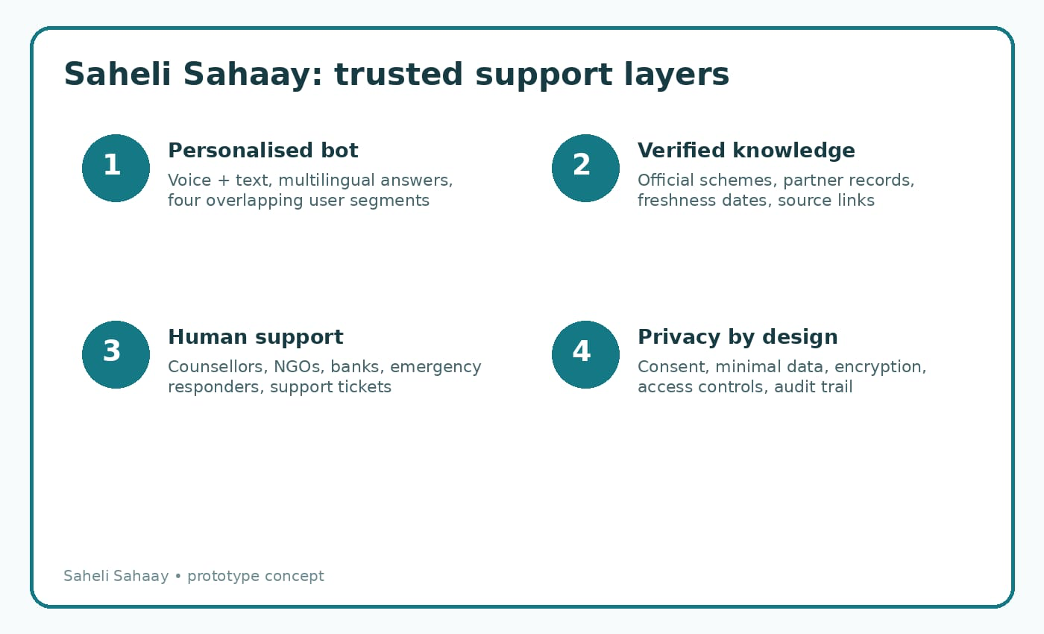

References
1. myScheme - Digital India | Leading the transformation in India for ease of living and digital economy | MeitY, Government of India. https://www.digitalindia.gov.in/initiative/myscheme/
2. Home | National Social Assistance Programme (NSAP)|Ministry of Rural Development | GoI. https://nsap.nic.in/
3. Sustainable Livelihood Initiative. https://www.hdfc.bank.in/sustainable-livelihood-initiative
4. Women Entrepreneur Cell | Central Bank of India. https://centralbank.bank.in/en/Women_Entrepreneur_Cell

